Community Health Improvement Plan Issue Prioritization Results
Thank you for participating in the Community Health Improvement Plan (CHIP) Issue Prioritization Meeting on December 8, 2021. In the results, below, you will see that the top two issues with the highest average scores were: 1) Mental Healthcare Access and 2) Housing. The two main issues that will be the focus of the 2022-2024 CHIP are Mental Health (both Mental Healthcare Access and Mental Health Indicators) and Housing. It was decided that both Mental Healthcare Access and Mental Health Indicators would be a focus of the CHIP because of the previous work by the Thriving Weld Healthy Mind and Spirit Workgroup which focused on both these aspects of mental health.
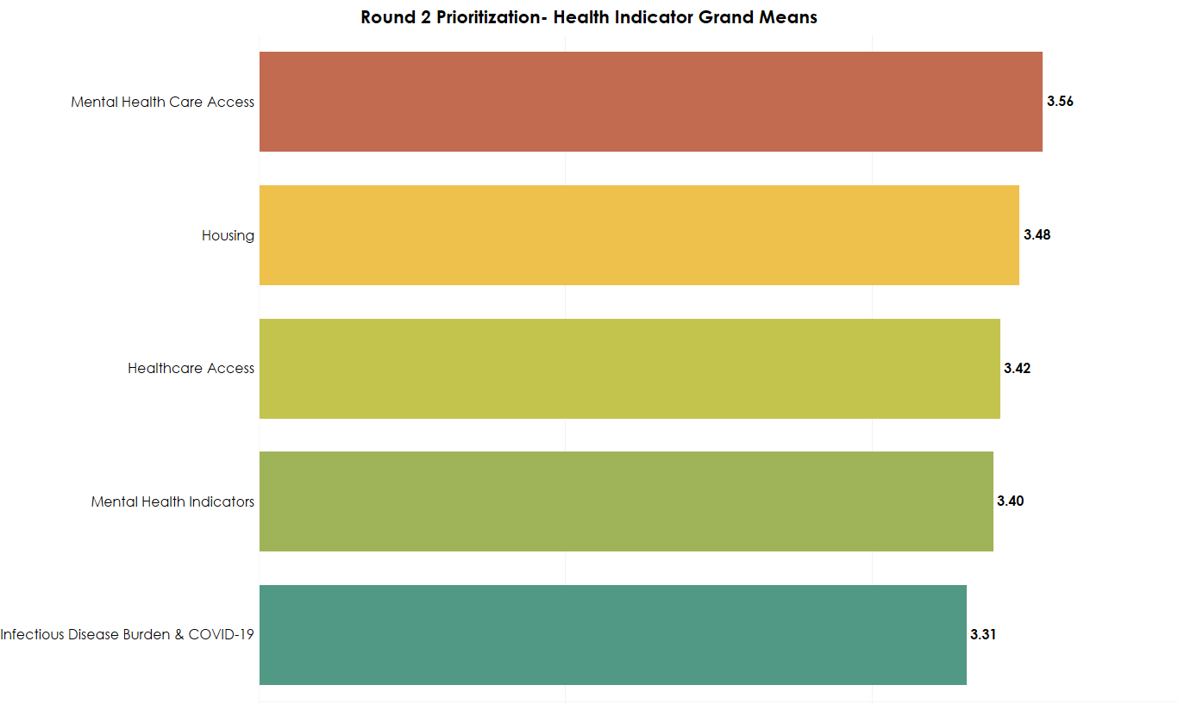
Next Steps
Up to this point, Thriving Weld and the Weld County CHIP have been synonymous. As we move forward the existing strategies (i.e., Thriving Weld and it’s six key focus areas = Healthy Eating, Active Living, Healthy Mind and Spirit, Access to Care, Education, and Livelihood) will continue in addition to new strategies that will be outlined in the 2022-2024 CHIP for Affordable Housing. (The Healthy Mind and Spirit Workgroup, focused on Mental Health, will review and update its strategies for the new CHIP).
Summary of Prioritization Process
Below is a summary of the prioritization process that was undertaken to identify the key health issues for the 2022-2024 CHIP. The initial Top 10 health issues were identified through a careful examination of WCDPHE’s 2021 Health Determinants and Assessment Report. These Top 10 heath issues were then voted on by a group of community partners from various health and human service providers in Weld County in late October 2021. This initial round of prioritization led to five top health issues that were then voted on by Thriving Weld Coalition members at the Thriving Weld Annual Meeting in December 2021. The results of this 2nd Round prioritization can be seen above. The two health issues that will be the focus of the 2022-2024 CHIP are Mental Health and Housing.
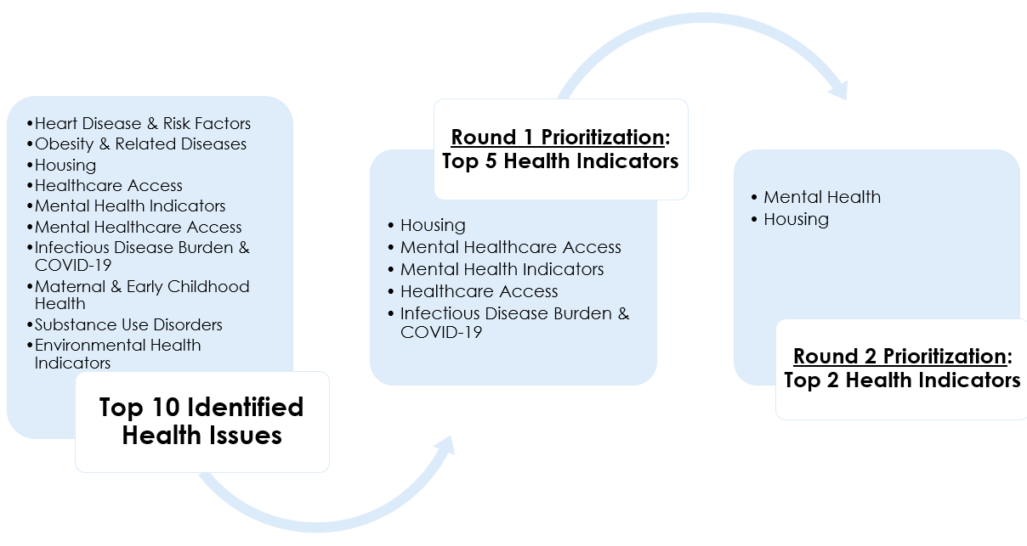
A Note on the Calculations
For each health issue, each criterion (size, seriousness, disproportionate impact, ability to impact, and importance to community) was averaged. Then all criteria for that health issue were averaged for a final, overall score. Scales used were as follows:
High Importance/ Highly Likely = 4
Moderate Importance/ Moderately Likely = 3
Low Importance/ Less Likely = 2
Not Important/ Not Likely = 1

The graphic on the next page shows the average scores for each criterion (size, seriousness, disproportionate impact, ability to impact, and importance to community) within each of the five health issues for Round 2 of Health Issue Prioritization.

